Dear Driver Instructors,
At DriveitHOME, an initiative of the National Safety Council in partnership with GM, our goal is to get parents and caregivers more involved in the driver education process so that they can help coach their teens to become safer drivers. That’s why we are excited to partner with you to help keep new drivers safe. You play a vital role in educating new drivers, and more parental involvement means more practice hours, reinforcement and experience for your students.
Whether you are hosting a parent night, communicating digitally with parents and caregivers, or just looking for free resources to build on your lessons, this toolkit will help you get parents and caregivers more involved with the following resources:
- DriveitHOME Free Resource Links
- DriveitHOME Logo
- Parent Letter Template
- Sample Newsletter/Email Promotional Copy
We encourage you to access and use our DriveitHOME resources at Driveithome.org. If there is anything else you need, please reach out to us at driveithome@nsc.org. Working together, we can help more parents and caregivers prioritize the safety of their new drivers.
DriveitHOME Free Resource Links
DriveitHOME Website
Your one-stop shop for resources to get parents and caregivers involved as their teens learn to drive. These National Safety Council resources are free to use and have been reviewed by a driver education professional.
The New Driver Deal
Before teens get behind the wheel, it’s important for them to have a discussion with their parents or caregivers about the rules and expectations for a safe driver on the road. Our New Driver Deal is a written document designed to ensure these rules are understood and followed. It can help families sort out all of the questions that arise when teen drivers get behind the wheel, like:
- When can the car be used?
- Who will pay for gas and insurance?
- What are the rules around major driving risks, such as passengers and distractions?
As new drivers gain experience, their parents or caregivers may want to give them more responsibility. Or, if a teen isn’t following the rules, they may need to be tightened. The New Driver Deal will help take the guesswork out of this process.
Pointers for Parents
The best way for a new driver to build experience is by spending time behind the wheel with a trusted, experienced driver. Our Pointers for Parents make this easy for parents and teens by providing week-by-week ideas for practice sessions based around the changing experience levels of new drivers. Parents just sign up for the lessons that are most applicable to their teen’s skill level, then they’ll receive a free lesson in their inbox each week for 16 weeks. Once they complete a set of lessons, they can continue right into the next set to continue building their teen’s skills.
Employer Resources
While teens aren’t the only drivers on the road, they are the most inexperienced and some of the riskiest. That means that helping to make teens safer behind the wheel can help make the roads safer for everyone. The DriveitHOME Employer Resources make it easy to spread the message of teen safe driving in workplaces, communities and within other organizations. These resources include posters, a safety talk, instructional videos on key driving skills and more.
DriveitHOME Logo
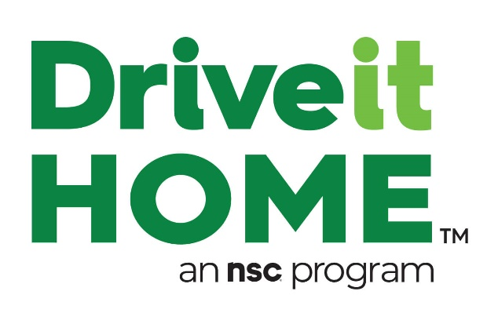
Parent Letter Template
Subject line: Free National Safety Council Resources
Hello Parents,
It’s an exciting time when your teen learns to drive, but it can also be nerve-wracking, challenging and time-consuming. Despite these roadblocks, it is absolutely vital that you get and stay involved with your teen behind the wheel. Parents and caregivers are the biggest influence on teen drivers, and your involvement will help ensure that your teen becomes a safe, responsible driver.
To help you get and stay involved, the National Safety Council offers a free program for parents called DriveitHOME, available at Driveithome.org. This program features realistic ideas for weekly practice drives to build your teen’s skills, as well as a customizable parent-teen driving agreement to get you both on the same page about risks and responsibilities behind the wheel.
Everything your teen learns in class should be reinforced on practice drives with you, and DriveitHOME will help make this easy with lessons based on their current skill level. Just visit Driveithome.org and take a look at the free Pointers for Parents lessons to get started.
Suggested Activity/Assignment
- Ask your students to talk with their parents and/or caregivers about driving responsibilities using the New Driver Deal
- Encourage your students to work with their families come up with two unique rules for their New Driver Deal: one for themselves and one for their parents/caregivers
- Take a moment during class to have some of your students share their rules and discuss how they came up with them
Sample Newsletter and Email Promotional Language
You can use the below language and links to share out information on DriveitHOME in emails or newsletters.
Subject Line/Headline: Get Parents Involved in Teen Driver Safety with DriveitHOME
Car crashes are the leading cause of preventable death for teens, but parents and caregivers can make a difference. DriveitHOME™, an initiative of the National Safety Council, offers free resources to help teens build experience behind the wheel.
DriveitHOME resources include:
- The New Driver Deal, a parent-teen driving agreement
- Pointers for Parents, a comprehensive collection of driving lessons designed around the changing experience levels of teen drivers
- Employer Resources to engage your workforce on teen driver safety
- Video lessons on key driving techniques
- Blog posts on timely topics
- Customized presentations on pressing teen driver issues
Though some parents or caregivers might assume they have no role to play in their teen’s driver education, we know that they are crucial to this process. DriveitHOME makes it easy to get on the same page and stay involved with new drivers, even after they are licensed.
Get started at DriveitHOME.org and email driveithome@nsc.org to learn more about partnership opportunities.

